AI-Powered Cloud Digital Carbon Passport Framework for Sustainable IT Infrastructure using Green AI and Carbon Intelligence Analytics

  - Bharath D Singh(24BIT0458)
Rahul Padmanaban(24BIT0473)
K. Ratna Subhash(24BIT0489)

1. Abstract
The rapid advancement of cloud computing and Artificial Intelligence (AI) has transformed the way organizations manage and deploy digital infrastructure. However, the increasing use of cloud services has also resulted in higher energy consumption and carbon emissions, raising concerns about environmental sustainability. Existing cloud management systems primarily focus on performance, resource utilization, and operational costs, while providing limited support for monitoring and reducing the carbon footprint of cloud resources. This creates challenges for organizations in achieving sustainability goals and complying with environmental regulations.
The proposed project, AI-Powered Cloud Digital Carbon Passport Framework for Sustainable IT Infrastructure using Green AI and Carbon Intelligence Analytics, introduces an intelligent cloud-based framework that continuously monitors cloud resource utilization, estimates carbon emissions, and generates a Digital Carbon Passport for every cloud resource. The passport records essential sustainability information such as energy consumption, carbon footprint, resource efficiency, historical emission records, and AI-generated optimization recommendations.
The framework utilizes Green AI techniques and Carbon Intelligence Analytics to predict future carbon emissions, identify inefficient workloads, and recommend energy-efficient resource allocation strategies. A centralized dashboard provides real-time visualization of carbon metrics, sustainability scores, and analytical reports, enabling organizations to make environmentally responsible decisions.
The proposed solution is implemented using Amazon EC2, Amazon S3, Amazon RDS, AWS Lambda, Amazon SageMaker, Amazon API Gateway, Amazon Cognito, Amazon CloudWatch, Amazon SNS, Amazon QuickSight, AWS Glue, Amazon Athena, Amazon EventBridge, and AWS Identity and Access Management (IAM). The framework aims to improve cloud sustainability, reduce carbon emissions, optimize resource utilization, and support organizations in achieving long-term environmental sustainability objectives.

2. Problem Statement
Cloud computing has become an essential component of modern digital infrastructure, supporting businesses, educational institutions, healthcare organizations, financial services, and government systems. As organizations continue migrating applications and services to the cloud, the demand for computational resources, storage, and networking has increased significantly. This rapid growth has resulted in higher electricity consumption and increased carbon emissions from cloud data centers.
Current cloud monitoring platforms mainly focus on system availability, resource utilization, application performance, and operational costs. Although these platforms provide valuable operational insights, they offer limited capabilities for monitoring environmental sustainability. Organizations often lack a standardized mechanism to measure, analyze, and maintain the carbon footprint generated by individual cloud resources throughout their lifecycle.
Furthermore, existing solutions do not provide intelligent prediction of future carbon emissions or personalized recommendations for reducing environmental impact. The absence of comprehensive sustainability monitoring makes it difficult for organizations to identify energy-inefficient resources, implement carbon-aware resource management strategies, and achieve Environmental, Social, and Governance (ESG) objectives.
Therefore, there is a need for an intelligent cloud-based framework that integrates Artificial Intelligence, Green AI, and Carbon Intelligence Analytics to continuously monitor cloud resources, estimate carbon emissions, generate Digital Carbon Passports, predict future sustainability trends, and provide automated recommendations for improving energy efficiency and reducing the environmental impact of cloud infrastructure.

3. Literature Survey and Individual Research Gap Analysis
Project: AI-Powered Cloud Digital Carbon Passport Framework for Sustainable IT Infrastructure using Green AI and Carbon Intelligence Analytics.
Student | Paper | Method & Dataset | Key Findings / Advantages | Limitations | Research Gap | Proposed Improvement
Rahul Padmanaban | Paper 1: Green AI Review | Uses review/survey methods and published datasets to study sustainable AI, cloud computing, and Digital Product Passports. | Identifies energy-efficient practices that improve sustainability while maintaining performance. | Largely theoretical with limited real-time cloud validation. | Lacks integrated AI carbon intelligence, cloud monitoring, and Digital Carbon Passport generation for end-to-end management. | Build an AI-powered cloud platform for carbon estimation, Green AI analytics, and automatic Digital Carbon Passport generation.
Rahul Padmanaban | Paper 2: Energy-Efficient Cloud | Uses review/survey methods and published datasets to study sustainable AI, cloud computing, and Digital Product Passports. | Identifies energy-efficient practices that improve sustainability while maintaining performance. | Largely theoretical with limited real-time cloud validation. | Lacks integrated AI carbon intelligence, cloud monitoring, and Digital Carbon Passport generation for end-to-end management. | Build an AI-powered cloud platform for carbon estimation, Green AI analytics, and automatic Digital Carbon Passport generation.
Rahul Padmanaban | Paper 3: Green Computing Survey | Uses review/survey methods and published datasets to study sustainable AI, cloud computing, and Digital Product Passports. | Identifies energy-efficient practices that improve sustainability while maintaining performance. | Largely theoretical with limited real-time cloud validation. | Lacks integrated AI carbon intelligence, cloud monitoring, and Digital Carbon Passport generation for end-to-end management. | Build an AI-powered cloud platform for carbon estimation, Green AI analytics, and automatic Digital Carbon Passport generation.
Rahul Padmanaban | Paper 4: Carbon Reduction in Data Centers | Uses review/survey methods and published datasets to study sustainable AI, cloud computing, and Digital Product Passports. | Identifies energy-efficient practices that improve sustainability while maintaining performance. | Largely theoretical with limited real-time cloud validation. | Lacks integrated AI carbon intelligence, cloud monitoring, and Digital Carbon Passport generation for end-to-end management. | Build an AI-powered cloud platform for carbon estimation, Green AI analytics, and automatic Digital Carbon Passport generation.
Rahul Padmanaban | Paper 5: AI Lifecycle Carbon | Uses review/survey methods and published datasets to study sustainable AI, cloud computing, and Digital Product Passports. | Identifies energy-efficient practices that improve sustainability while maintaining performance. | Largely theoretical with limited real-time cloud validation. | Lacks integrated AI carbon intelligence, cloud monitoring, and Digital Carbon Passport generation for end-to-end management. | Build an AI-powered cloud platform for carbon estimation, Green AI analytics, and automatic Digital Carbon Passport generation.
Kothamasu Ratna Subhash | Paper 6: Green & Sustainable AI | Uses review/survey methods and published datasets to study sustainable AI, cloud computing, and Digital Product Passports. | Identifies energy-efficient practices that improve sustainability while maintaining performance. | Largely theoretical with limited real-time cloud validation. | Lacks integrated AI carbon intelligence, cloud monitoring, and Digital Carbon Passport generation for end-to-end management. | Build an AI-powered cloud platform for carbon estimation, Green AI analytics, and automatic Digital Carbon Passport generation.
Kothamasu Ratna Subhash | Paper 7: AI Sustainability Strategies | Uses review/survey methods and published datasets to study sustainable AI, cloud computing, and Digital Product Passports. | Identifies energy-efficient practices that improve sustainability while maintaining performance. | Largely theoretical with limited real-time cloud validation. | Lacks integrated AI carbon intelligence, cloud monitoring, and Digital Carbon Passport generation for end-to-end management. | Build an AI-powered cloud platform for carbon estimation, Green AI analytics, and automatic Digital Carbon Passport generation.
Kothamasu Ratna Subhash | Paper 8: Beyond Carbon Emissions | Uses review/survey methods and published datasets to study sustainable AI, cloud computing, and Digital Product Passports. | Identifies energy-efficient practices that improve sustainability while maintaining performance. | Largely theoretical with limited real-time cloud validation. | Lacks integrated AI carbon intelligence, cloud monitoring, and Digital Carbon Passport generation for end-to-end management. | Build an AI-powered cloud platform for carbon estimation, Green AI analytics, and automatic Digital Carbon Passport generation.
Kothamasu Ratna Subhash | Paper 9: Digital Carbon Footprint Assessment | Uses review/survey methods and published datasets to study sustainable AI, cloud computing, and Digital Product Passports. | Identifies energy-efficient practices that improve sustainability while maintaining performance. | Largely theoretical with limited real-time cloud validation. | Lacks integrated AI carbon intelligence, cloud monitoring, and Digital Carbon Passport generation for end-to-end management. | Build an AI-powered cloud platform for carbon estimation, Green AI analytics, and automatic Digital Carbon Passport generation.
Kothamasu Ratna Subhash | Paper 10: Digital Product Passports Review | Uses review/survey methods and published datasets to study sustainable AI, cloud computing, and Digital Product Passports. | Identifies energy-efficient practices that improve sustainability while maintaining performance. | Largely theoretical with limited real-time cloud validation. | Lacks integrated AI carbon intelligence, cloud monitoring, and Digital Carbon Passport generation for end-to-end management. | Build an AI-powered cloud platform for carbon estimation, Green AI analytics, and automatic Digital Carbon Passport generation.
Bharath D Singh | Paper 11: DPP Systems | Uses review/survey methods and published datasets to study sustainable AI, cloud computing, and Digital Product Passports. | Identifies energy-efficient practices that improve sustainability while maintaining performance. | Largely theoretical with limited real-time cloud validation. | Lacks integrated AI carbon intelligence, cloud monitoring, and Digital Carbon Passport generation for end-to-end management. | Build an AI-powered cloud platform for carbon estimation, Green AI analytics, and automatic Digital Carbon Passport generation.
Bharath D Singh | Paper 12: DPP Impact Model | Uses review/survey methods and published datasets to study sustainable AI, cloud computing, and Digital Product Passports. | Identifies energy-efficient practices that improve sustainability while maintaining performance. | Largely theoretical with limited real-time cloud validation. | Lacks integrated AI carbon intelligence, cloud monitoring, and Digital Carbon Passport generation for end-to-end management. | Build an AI-powered cloud platform for carbon estimation, Green AI analytics, and automatic Digital Carbon Passport generation.
Bharath D Singh | Paper 13: AI & DPP | Uses review/survey methods and published datasets to study sustainable AI, cloud computing, and Digital Product Passports. | Identifies energy-efficient practices that improve sustainability while maintaining performance. | Largely theoretical with limited real-time cloud validation. | Lacks integrated AI carbon intelligence, cloud monitoring, and Digital Carbon Passport generation for end-to-end management. | Build an AI-powered cloud platform for carbon estimation, Green AI analytics, and automatic Digital Carbon Passport generation.
Bharath D Singh | Paper 14: IoT to DPP | Uses review/survey methods and published datasets to study sustainable AI, cloud computing, and Digital Product Passports. | Identifies energy-efficient practices that improve sustainability while maintaining performance. | Largely theoretical with limited real-time cloud validation. | Lacks integrated AI carbon intelligence, cloud monitoring, and Digital Carbon Passport generation for end-to-end management. | Build an AI-powered cloud platform for carbon estimation, Green AI analytics, and automatic Digital Carbon Passport generation.
Bharath D Singh | Paper 15: DPP Research Agenda | Uses review/survey methods and published datasets to study sustainable AI, cloud computing, and Digital Product Passports. | Identifies energy-efficient practices that improve sustainability while maintaining performance. | Largely theoretical with limited real-time cloud validation. | Lacks integrated AI carbon intelligence, cloud monitoring, and Digital Carbon Passport generation for end-to-end management. | Build an AI-powered cloud platform for carbon estimation, Green AI analytics, and automatic Digital Carbon Passport generation.

4. Research Gap Analysis
The literature survey indicates that although significant research has been conducted on Green AI, sustainable cloud computing, carbon footprint assessment, and Digital Product Passports (DPPs), these studies primarily address these domains independently rather than as an integrated solution. Most existing approaches focus on energy-efficient computing, carbon reduction strategies, or sustainability frameworks but lack a unified AI-driven platform that continuously monitors cloud infrastructure, estimates carbon emissions in real time, and generates Digital Carbon Passports. Furthermore, many proposed solutions are theoretical or domain-specific, with limited validation in real-world cloud environments. Current research also provides minimal support for intelligent decision-making through predictive carbon analytics and automated sustainability reporting. Therefore, there is a clear need for an end-to-end AI-powered cloud framework that combines Green AI techniques, continuous carbon intelligence analytics, real-time cloud monitoring, and automated Digital Carbon Passport generation to enable transparent, scalable, and intelligent sustainable IT infrastructure management.

5. Project Objectives
The primary objectives of the proposed system are:
- To develop an AI-powered framework for continuously monitoring the carbon emissions of cloud infrastructure.
- To design and implement a Digital Carbon Passport that maintains sustainability information for every cloud resource.
- To utilize Green AI techniques for predicting future carbon emissions and identifying energy-inefficient cloud resources.
- To integrate AWS cloud services for secure, scalable, automated, and reliable cloud sustainability management.
- To provide an interactive dashboard for visualizing carbon emissions, sustainability scores, AI predictions, and environmental analytics.
- To support organizations in reducing carbon emissions and achieving sustainable cloud computing through intelligent resource optimization.

6. Novelty Summary
Most existing cloud monitoring platforms concentrate on performance optimization, infrastructure management, and operational cost reduction while paying limited attention to environmental sustainability. The proposed project introduces an innovative AI-Powered Cloud Digital Carbon Passport Framework that combines Artificial Intelligence, Green AI, and Carbon Intelligence Analytics to improve sustainable cloud infrastructure management.
Unlike traditional monitoring systems, the proposed framework generates a unique Digital Carbon Passport for every cloud resource. This passport maintains a complete sustainability profile, including carbon emissions, energy consumption, sustainability score, resource efficiency, historical carbon records, and AI-generated optimization recommendations throughout the lifecycle of the cloud resource.
The framework incorporates Green AI techniques to analyze cloud utilization patterns, predict future carbon emissions, and recommend intelligent resource optimization strategies such as workload redistribution, resource right-sizing, and energy-efficient scheduling. Carbon Intelligence Analytics further enables organizations to visualize sustainability trends through interactive dashboards and automated reports.
The proposed system also leverages AWS cloud services to provide secure authentication, scalable storage, serverless processing, AI model deployment, real-time monitoring, automated notifications, and business intelligence dashboards. This integrated approach enhances scalability, improves prediction accuracy, increases automation, strengthens security, and promotes environmentally sustainable cloud computing practices.
Novel Features
- AI-based prediction of cloud carbon emissions.
- Digital Carbon Passport for every cloud resource.
- Green AI-powered sustainability optimization.
- Carbon Intelligence Analytics for real-time monitoring.
- Automated sustainability scoring mechanism.
- Interactive carbon analytics dashboard.
- AI-driven optimization recommendations.
- Secure and scalable AWS cloud architecture.
- Automated alert and reporting system.
- Support for sustainable cloud infrastructure and ESG initiatives.

7. AWS Cloud Architecture
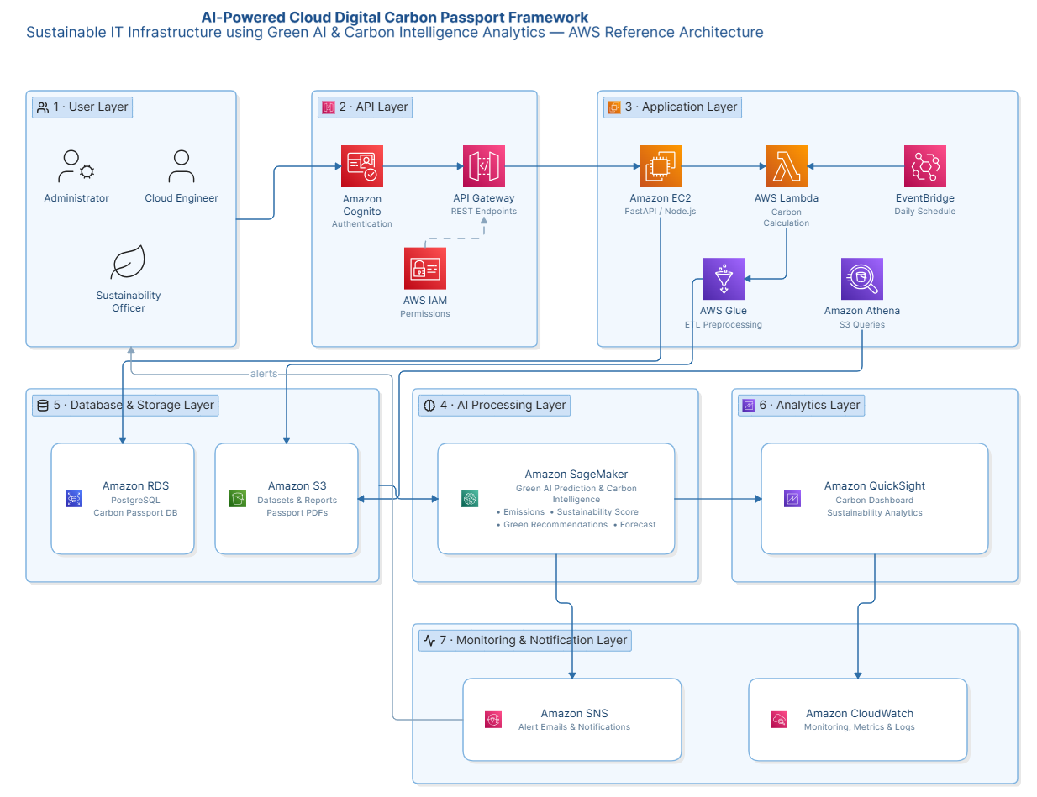
Figure 7.1: AWS Cloud Architecture for AI-Powered Cloud Digital Carbon Passport Framework for Sustainable IT Infrastructure using Green AI and Carbon Intelligence Analytics.
Description:
The AWS Cloud Architecture illustrates the interaction between users, AWS cloud services, databases, AI services, monitoring components, and visualization tools. The architecture integrates Amazon Cognito for authentication, Amazon API Gateway for API communication, Amazon EC2 for application hosting, Amazon RDS and Amazon S3 for storage, AWS Lambda for serverless processing, Amazon SageMaker for AI model training and prediction, Amazon CloudWatch for monitoring, Amazon QuickSight for analytics dashboards, Amazon SNS for notifications, AWS Glue and Amazon Athena for data processing and analytics, and AWS IAM for secure resource access. This architecture provides a scalable, secure, and intelligent cloud environment for monitoring and managing carbon emissions across cloud infrastructure.

8. Complete System Architecture
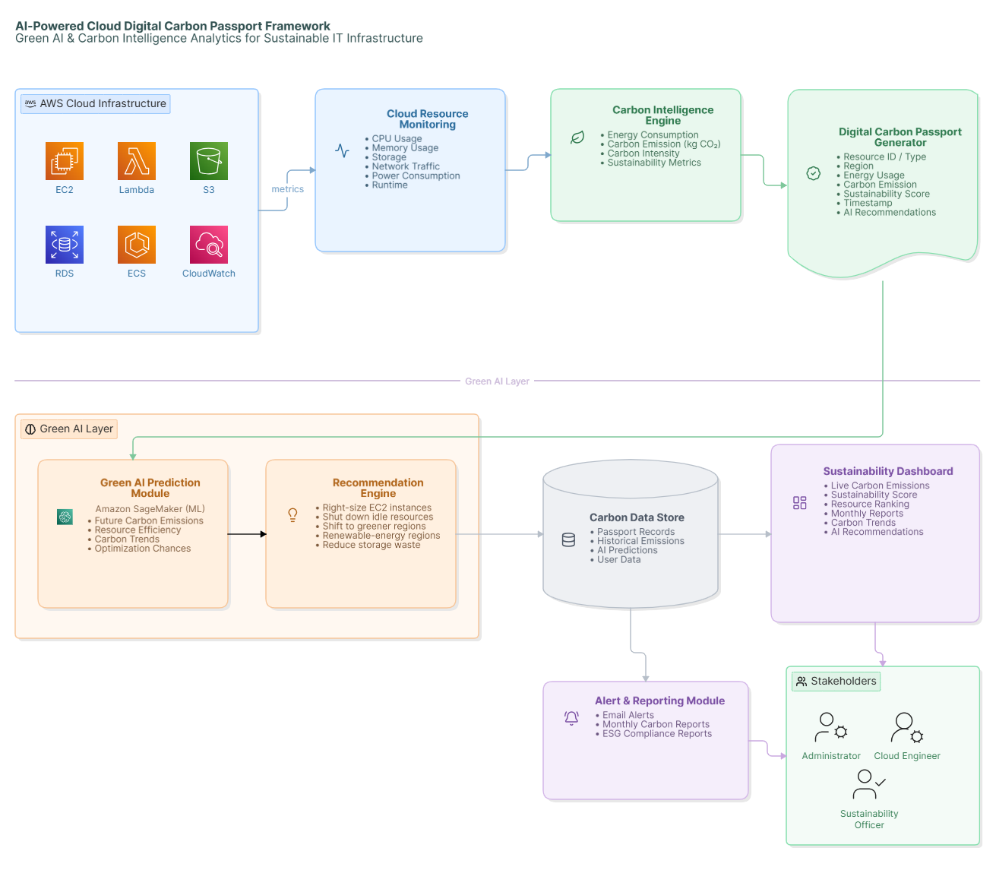Figure 8.1: Complete System Architecture of the AI-Powered Cloud Digital Carbon Passport Framework for Sustainable IT Infrastructure using Green AI and Carbon Intelligence Analytics.
Description
The Complete System Architecture illustrates the end-to-end workflow of the proposed framework. The system begins by collecting cloud infrastructure metrics such as CPU utilization, memory usage, storage consumption, network traffic, runtime, and power consumption from various AWS cloud resources. These metrics are processed by the Carbon Intelligence Analytics Engine to estimate energy consumption, carbon emissions, and sustainability indicators.
The processed information is then forwarded to the Digital Carbon Passport Generator, which creates and updates a unique Digital Carbon Passport for every cloud resource. Each passport stores essential sustainability information including carbon emissions, energy usage, sustainability score, cloud region, resource type, historical records, and AI-generated recommendations.
The Green AI Prediction Module analyzes historical resource utilization and predicts future carbon emissions using machine learning techniques. Based on these predictions, the Recommendation Engine suggests optimization strategies such as resource right-sizing, workload migration to greener regions, efficient scheduling, and idle resource removal.
Finally, all processed information is stored in the database and displayed through an interactive dashboard that provides real-time carbon analytics, sustainability reports, resource rankings, historical trends, and automated alerts. This architecture enables organizations to continuously monitor and improve the environmental sustainability of their cloud infrastructure.

9. Dataset Details
Dataset Name
Cloud Carbon Footprint and Cloud Resource Utilization Dataset (Combined Dataset)

Dataset Source
The proposed framework utilizes a combined dataset created from multiple publicly available cloud sustainability resources and cloud monitoring datasets.
The data sources include:
- Electricity Maps
- Cloud Carbon Footprint Open Dataset
- AWS CloudWatch Metrics (Sample Monitoring Data)
- Kaggle Cloud Resource Utilization Dataset

Dataset URL
- https://www.electricitymaps.com/data-portal
- https://www.cloudcarbonfootprint.org/
- https://www.kaggle.com/

Dataset Size
Approximately 50–100 MB

Number of Records
Approximately 100,000 cloud resource records

Number of Features
Approximately 15–20 features

Data Type
The dataset consists of:
- Numerical Data
- Categorical Data
- Time-Series Data

Features Included
The dataset contains the following features:
- Resource ID
- Cloud Service Type
- AWS Region
- EC2 Instance Type
- CPU Utilization (%)
- Memory Usage (%)
- Storage Utilization (GB)
- Network Traffic
- Runtime (Hours)
- Power Consumption (kWh)
- Carbon Intensity (gCO₂/kWh)
- Estimated Carbon Emission (kgCO₂)
- Renewable Energy Percentage
- Sustainability Score
- Timestamp
- Resource Status

Purpose of the Dataset
The dataset is used to:
- Monitor cloud resource utilization.
- Calculate carbon emissions generated by cloud resources.
- Train Artificial Intelligence models for carbon prediction.
- Generate Digital Carbon Passports.
- Produce sustainability reports.
- Recommend energy-efficient cloud resource optimization.

Preprocessing Techniques
Before training the AI model, the dataset undergoes the following preprocessing steps:
- Removal of duplicate records
- Missing value handling
- Data normalization
- Feature scaling
- Categorical encoding
- Outlier detection
- Timestamp conversion
- Feature selection
- Training and testing data split

Dataset License
Publicly Available / Open Source (Subject to individual dataset licenses)

10. AWS Services Planning
AWS Service | Purpose
Amazon EC2 | Hosts the backend application and business logic of the Digital Carbon Passport Framework.
Amazon API Gateway | Provides secure REST APIs for communication between frontend and backend services.
Amazon Cognito | Authenticates users and manages secure login for administrators and sustainability officers.
AWS IAM | Controls secure access and permissions for AWS resources.
Amazon RDS (PostgreSQL) | Stores Digital Carbon Passport records, user information, AI predictions, and sustainability reports.
Amazon S3 | Stores datasets, carbon reports, exported passport documents, and historical logs.
AWS Lambda | Performs serverless carbon emission calculations and event-driven data processing.
Amazon SageMaker | Trains, deploys, and manages machine learning models for carbon prediction and optimization.
Amazon CloudWatch | Collects cloud resource metrics, monitors application health, and stores operational logs.
Amazon SNS | Sends automated alerts and notifications when carbon thresholds exceed predefined limits.
Amazon QuickSight | Creates dashboards, reports, and visual analytics for sustainability monitoring.
AWS Glue | Cleans, transforms, and preprocesses cloud resource data before AI model training.
Amazon Athena | Queries large sustainability datasets stored in Amazon S3 using SQL.
Amazon EventBridge | Schedules automated monitoring tasks, AI predictions, and report generation.

11. GitHub Repository Structure
GitHub Repository Structure
The project follows a modular GitHub repository structure to ensure maintainability, collaboration, and proper organization of project resources. The repository is divided into separate directories for documentation, architecture diagrams, datasets, source code, experimental results, and presentation materials.
Repository Name
CloudCarbonPassport_Cloud_Project_2026
Repository Structure
CloudCarbonPassport_Cloud_Project_2026
│
├── README.md
├── .gitignore
│
├── docs/
│ ├── README.md
│ ├── Abstract.md
│ ├── Literature_Survey.md
│ ├── Research_Gap.md
│ ├── Objectives.md
│ ├── Novelty.md
│ ├── Dataset_Details.md
│ ├── AWS_Services.md
│ └── Work_Distribution.md
│
├── architecture/
│ ├── README.md
│ ├── AWS_Architecture.md
│ ├── System_Architecture.md
│ └── Workflow.md
│
├── dataset/
│ ├── README.md
│ ├── dataset_description.md
│ ├── raw/
│ │ └── README.md
│ └── processed/
│ └── README.md
│
├── src/
│ ├── frontend/
│ │ └── README.md
│ ├── backend/
│ │ └── README.md
│ ├── ml_model/
│ │ └── README.md
│ └── aws/
│ └── README.md
│
├── results/
│ └── README.md
│
└── presentation/
└── README.md
Description of Repository Folders
Folder | Description
docs/ | Contains all project documentation including abstract, objectives, literature survey, research gap analysis, dataset details, AWS services planning, novelty summary, and work distribution.
architecture/ | Stores AWS Cloud Architecture, Complete System Architecture, workflow diagrams, and architecture documentation.
dataset/ | Contains raw datasets, processed datasets, dataset description, and preprocessing information used for AI model development.
src/ | Includes the complete project source code, divided into frontend, backend, machine learning models, and AWS integration modules.
results/ | Stores screenshots, performance graphs, experimental outputs, carbon analytics reports, and evaluation results.
presentation/ | Contains project presentation slides, review materials, and demonstration documents.
This structured repository organization improves project readability, simplifies collaboration among team members, and enables efficient maintenance throughout the project lifecycle.

12. GitHub Workflow
GitHub Workflow
The project follows a collaborative GitHub workflow to support parallel development, version control, and efficient code management. Each team member contributes independently through feature branches while maintaining a stable development branch before merging changes into the main branch.
Branch Structure
main
│
└── develop
├── feature/student1
├── feature/student2
└── feature/student3
Workflow Process
- Create the GitHub repository named CloudCarbonPassport_Cloud_Project_2026.
- Initialize the repository with a main branch.
- Create a develop branch for integrating project components.
- Each team member creates an individual feature branch:
  - feature/student1
  - feature/student2
  - feature/student3
- Each student works independently within their assigned branch and commits changes regularly.
- After completing a task, a Pull Request (PR) is created from the respective feature branch to the develop branch.
- Team members review the proposed changes to ensure code quality and documentation consistency.
- Any merge conflicts identified during the review process are resolved before approval.
- Once approved, the changes are merged into the develop branch.
- After all modules have been integrated and tested successfully, the develop branch is merged into the main branch.
- A version tag (e.g., v1.0-Phase1) is created to mark the completion of Project Phase-I.
Team Collaboration Strategy
Team Member | Primary Responsibility
Student 1 | Project documentation, AWS architecture, dataset planning, report preparation, and references.
Student 2 | Literature survey, research gap analysis, and related documentation.
Student 3 | GitHub repository management, repository structure, workflow implementation, and project organization.
Expected GitHub Contributions
- Regular and meaningful commits from each team member.
- Independent feature branch development.
- Pull Requests for completed tasks.
- Peer review before merging changes.
- Continuous documentation updates.
- Proper version control and release management.
The adopted GitHub workflow promotes collaborative software development, minimizes merge conflicts, maintains project stability, and ensures traceability of individual contributions throughout the development lifecycle.

13. References
(Format these in IEEE style if your department requires it. Below is a clean numbered list.)
- A Systematic Review of Green AI (2023). https://arxiv.org/abs/2301.11047
- Energy-Efficiency and Sustainability in New Generation Cloud Computing: A Vision and Directions for Integrated Management of Data Centre Resources and Workloads (2023). https://arxiv.org/abs/2303.10572
- On the Opportunities of Green Computing: A Survey (2023). https://arxiv.org/abs/2311.00447
- Carbon Footprint Reduction for Sustainable Data Centers in Real-Time (2024). https://arxiv.org/abs/2403.14092
- Beyond Efficiency: A Systematic Review of Energy Consumption and Carbon Footprint Across the AI Lifecycle (2026). https://doi.org/10.3390/su18031359
- A Systematic Review of Green and Sustainable AI: Taxonomy, Metrics, Challenges, and Open Research Directions (2026). https://doi.org/10.3390/su18084115
- Strategies and Design for Increasing AI Sustainability (2026). https://www.nature.com/articles/s44359-026-00195-w
- Beyond the Carbon Emissions of Artificial Intelligence (AI): A Whole-Systems Energy and Environmental Sustainability Analysis of Datacenters in Denmark, Germany and Norway (2026). https://www.sciencedirect.com/science/article/pii/S2214629626003105
- Digital Carbon Footprint Assessment of Universitas Indonesia Data Center Based on the GHG Protocol (2026). https://link.springer.com/article/10.1007/s43621-026-03522-0
- A Comprehensive Review of Digital Product Passports in Sustainable Manufacturing: Current State, Challenges, and Future Directions (2026). https://link.springer.com/article/10.1007/s43615-026-00927-x
- Bridging Digital and Green Transitions: A Literature Review of Digital Product Passport Systems (2026). https://www.sciencedirect.com/science/article/abs/pii/S1364032125012730
- A Conceptual Model to Assess the Environmental Impacts of Digital Product Passports (2026). https://www.sciencedirect.com/science/article/pii/S2212827126006219
- Operationalising Digital Circularity: A Critical Systematic Review of Artificial Intelligence Applications to Material and Digital Product Passports (2026). https://www.mdpi.com/2075-5309/16/11/2048
- From IoT to Digital Product Passports: A Systematic Review of Product Carbon Footprint Management in the Metalworking Industry (2026). https://www.mdpi.com/2227-9717/14/15/2416
- Digital Product Passports for Advancing the Circular Economy: A Research Agenda (2026). https://doi.org/10.1145/3786158.3788558

